Title: Yahtzee

Overview: Yahtzee is a classic single-player dice game played with five six-sided dice, combining chance and strategy. The objective is to score the highest points by rolling specific combinations of dice. Players roll the dice up to three times in each turn, setting aside dice with each roll, aiming to achieve the highest-scoring combinations. The game consists of thirteen rounds, and each combination can only be used once per game. The goal is to reach the highest total score possible, which can then be compared to previous high scores.

Features:

1. Five six-sided dice: The game is played with five standard six-sided dice, with each die displaying numbers from 1 to 6.
2. Three rolls per turn: During each turn, players can roll the dice up to three times, setting aside any dice they wish to keep after each roll.
3. Scoring combinations: Players aim to achieve specific combinations of dice to score points. The possible combinations are:
   1. Ones, Twos, Threes, Fours, Fives, Sixes: A sum of the respective number rolled.
   2. Three-of-a-kind: Three dice with the same number. Scored as the sum of all five dice.
   3. Four-of-a-kind: Four dice with the same number. Scored as the sum of all five dice.
   4. Full House: One pair and one three-of-a-kind. Scores 25 points. e. Small Straight: A sequence of four consecutive numbers (e.g., 1-2-3-4, 2-3-4-5, or 3-4-5-6). Scores 30 points.
   5. Large Straight: A sequence of five consecutive numbers (e.g., 1-2-3-4-5 or 2-3-4-5-6). Scores 40 points.
   6. Yahtzee: All five dice with the same number. Scores 50 points.
   7. Chance: Any combination of dice. Scored as the sum of all five dice.
4. Upper Section Bonus: If a player scores a total of 63 points or more in the upper section (Ones through Sixes), they receive a bonus of 35 points.
5. Yahtzee Bonus: If a player rolls a second Yahtzee during the game, they score an additional 100 points, provided they already have a scored Yahtzee.
6. Joker Rule: If a player rolls a Yahtzee and has already filled in their Yahtzee category, they can use the Joker rule. The player must score the rolled Yahtzee in one of the open categories in the lower section or the corresponding upper section category if it is not yet filled.
7. Thirteen rounds: The game consists of thirteen rounds, during which players attempt to fill in each of the thirteen scoring categories.
8. Strategy and decision-making: Players must decide which dice to keep and which scoring category to aim for, balancing the probabilities and potential scores to maximize their total points.
9. High scores list: A high scores list is available in the main menu, allowing players to track their best performances and compare their scores to previous games.
10. Scoring sheets: The game uses scoring sheets to keep track of each player's points in each category, calculate bonuses, and determine the final scores.

UI/UX Design

Want to further refine the work breakdown structure list.

The UI will be 2 buttons at the bottom (Roll) and play. Above that there will be 5 dice. When the roll button is pressed there will be a animation on all the dice that aren't "held". When you click the dice you it holds them.

Above the roll, and dice, will be the scoring sheet. The scoring sheet will consist of a minor column and a major column. Within the minor column there will be 3 columns, the icon, the select button, and the players score. The major column will be identical. When the select button is pressed and the play button is pressed the select button will turn into the regular score.

The play button will show after the player used all 3 rolls in their turn. Their are 13 turns in total.

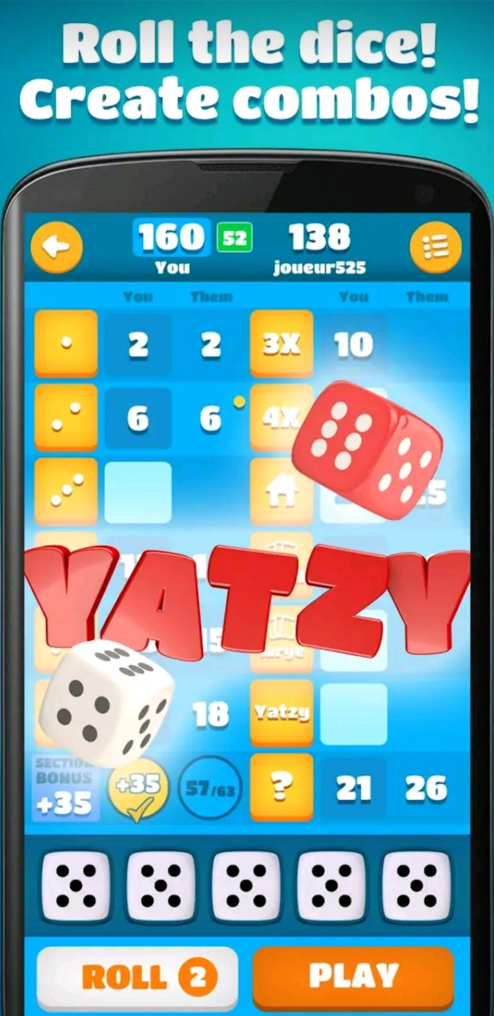<https://mail.google.com/mail/u/1?ui=2&ik=bc8389eded&attid=0.1&permmsgid=msg-f:1762271468584045608&th=1874d89052c20c28&view=att&disp=safe&realattid=1874d88ae06cf3806b1>